A21 – Online Cybersecurity Discussion
Platform: Reddit
Topic: Phishing email discussion
Thread URL:
https://www.reddit.com/r/cybersecurity/comments/1r3xz1l/suspected_phishing_email_from_microsoft/
My Contribution:
This is a good example of how phishing has evolved beyond just fake domains. Even if the sender domain looks legitimate, it does not guarantee the email is safe. Attackers can abuse trusted platforms or use compromised systems to send malicious emails.
I agree with others that checking email headers (SPF, DKIM, DMARC) is important, but many normal users do not know how to do this. So in real situations, it is better to verify the context of the email, avoid clicking links directly, and instead access services through official websites.
User awareness and cautious behaviour are still one of the most effective defenses against phishing attacks.

Summary:
For this activity, I participated in an online cybersecurity discussion on Reddit about suspected phishing emails from Microsoft domains. The discussion focused on how attackers can use legitimate-looking email addresses to trick users into believing the email is genuine.

I contributed by explaining that even if the sender appears legitimate, it does not guarantee that the email is safe. I also highlighted that users should verify the context of the email and avoid clicking on unknown links. Additionally, I mentioned that awareness and cautious behaviour are important in preventing phishing attacks.

This activity helped me understand how cybersecurity professionals analyse suspicious emails and how phishing attacks have become more advanced. It also improved my ability to communicate cybersecurity concepts clearly in an online discussion.

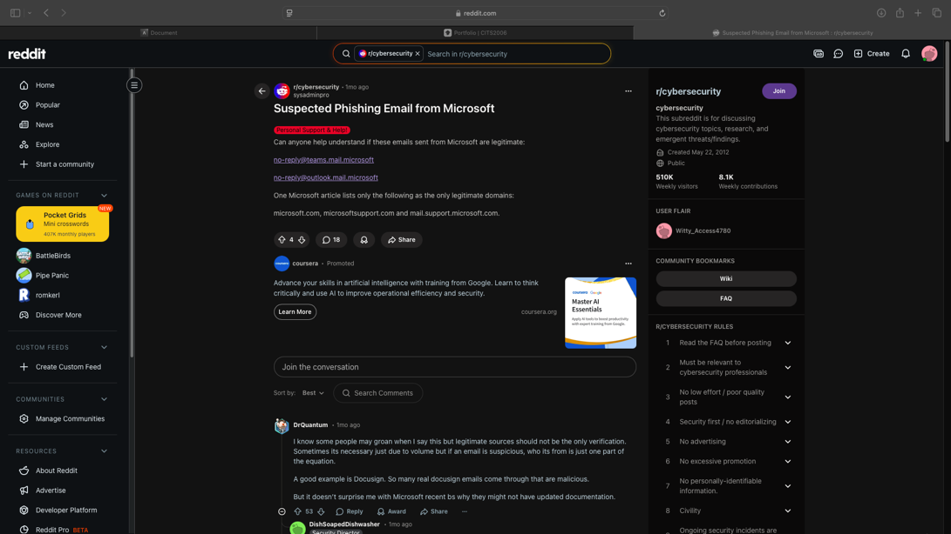
Evidence:
